HWW VOLUNTEER OPPORTUNITIES
Thank you so much for your interest in volunteering with us.
We are a small charity and the help of volunteers is invaluable to the progress of our work.
See below for specific volunteer opportunities. If you’d like to apply for any of these roles, then please fill out this form and email it to us as we may have other opportunities in the future.

Khatwa Marketing
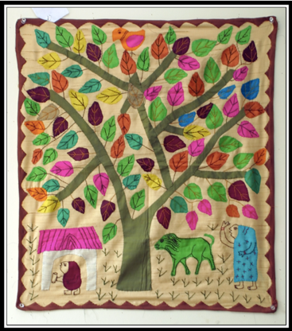
We are looking for a creative and motivated volunteer for a one-off project to help list and sell a range of textile Khatwa (applique) wall hangings, to raise much needed funds to support our work.
Each piece of Khatwa was made by homeworkers in Bijar, North India and was bought by HWW in the early 2000s.
The role will initially involve writing a short description of each piece and then listing the items on our website (and/or on etsy?). Once the items are listed there is the opportunity to help with marketing and promoting the sale.
Ideally, we would like to get the Khatwa listed by the end of October 2021 in time for the Christmas period.
If you have any other ideas about how we can sell the Khatwa we would love to hear them!

Khatwa Customer Service
Before we can go ahead with the khatwa marketing, we also need a volunteer who could process each order.

This means holding our stock of khatwa (currently stored in a large plastic box, approx. 100 cm x 50 cm x 75cm, here in Leeds), selecting the appropriate pieces ordered, ironing and packing them carefully, and then posting to the customer.

HWW will provide full training and cover postage and packing costs. Each package will take 30-45 minutes, depending on how good you are at ironing!

We’d like this to be up and running in time to attract some Christmas sales!

Background Brand Research
We’re currently working with partners on the Hidden Homeworkers project in South Asia, seeking to improve transparency and working conditions for homeworkers and other precarious women workers, see attached flyer. We also receive enquiries from brands discovering informal workers within their supply chains in other parts of the world.

If we are to carry out this work in an informed way, we need to carry out background research to find out more about the brand, and if possible, their sourcing arrangements, before we engage with them. As a result, we often have small research projects for which we need help - for example, completing desk based/internet research on specific brands or other organisations, or analysing supplier lists or other data (usually in the form of excel spreadsheets).

For this opportunity, you need basic skills in internet searching and for the supplier lists, use of excel spreadsheets. We currently have an urgent project that will need about 4 hours work to complete.

Fundraising Research
We are looking for a volunteer (or volunteers) to help us with our donor mapping. This involves firstly monitoring the circular e mails produced by potential funders and others advertising upcoming opportunities (these are set up to all come into a separate e mail address), and secondly, updating a spreadsheet we use to monitor potential donors and keep abreast of relevant deadlines etc. Information about potential donors then needs to be passed onto our fundraising team.

We estimate that this task will take between 45 – 60 minutes a week to complete.

If you are interested in any of these opportunities, please complete this form and email info@homeworkersww.org.uk.

Or if you’d like to talk to someone before you apply, please e mail lucy@homeworkersww.org.uk, saying which opportunity you are interested in.

