Jane Tate 1945 - 2018
Socialist feminist campaigner and organiser for human rights
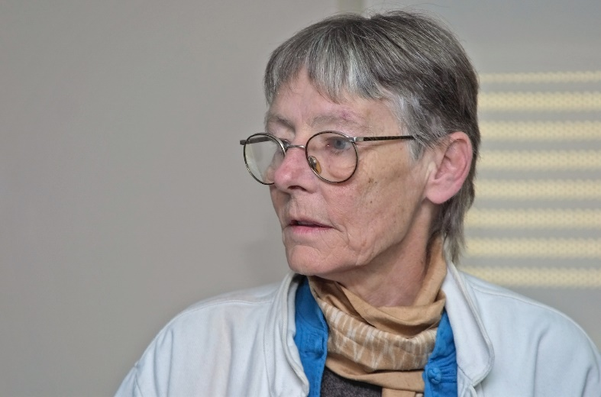
Our friend and colleague Jane Tate died at her home in Leeds in September after a long illness. Jane was an exceptionally determined, persistent and compassionate social activist. She dedicated her life to social justice and giving practical support to women, workers and migrants in their everyday lives and struggles for rights.
Jane, the eldest of three, was born in Cambridgeshire in 1945. The family settled in Shrewsbury, in 1953, where Jane’s mother Joan was an award-winning translator of Scandinavian literature, and her father Clive helped to found the Shropshire Wildlife Trust. Their home was welcoming and hospitable, and Jane’s parents hosted many visitors from other countries.
Soon after gaining a First in Chinese from Cambridge University, Jane moved to Hong Kong. The Vietnam war was raging; Jane supported American GIs and with them, campaigned against the war.
In 1973 Jane moved to Woodhouse in Leeds, where at first she lived communally. She was an active socialist feminist and political activist, briefly a teacher and then elected Shop Steward at Bray’s print factory where she worked.
Jane’s labour rights involvement continued when she left Bray’s, she worked at Strawberry Lane Community Centre and then as an outreach worker at the Yorkshire & Humberside Low Pay Unit. It was here that she first discovered and made contact with thousands of West Yorkshire homeworkers, women who worked at home for very low pay, sewing, soldering, packing, typing and much more. Most were employed completely informally, and had irregular work, without any rights to sick, holiday or severance pay.
In 1990 she documented the homeworkers’ conditions in A Penny a Bag: Campaigning on Homeworking (1990) and a video, Are You An Outworker? More staff were appointed, the work with homeworkers increased, and Jane helped establish the West Yorkshire Homeworking Group.
The work moved briskly ahead in the 1990s with a national survey of homeworking, links with homeworking projects around the country and the foundation of a national body to lobby for improved pay and rights for homeworkers. Jane helped found the National Group on Homeworking (NGH) and was a director for many years. NGH evolved from a previous organisation called the National Homeworking Unit, which had been based in Birmingham. Persistent lobbying by NGH ensured homeworkers were included in the Labour government’s National Minimum Wage Act in 1998, and given full rights to the national minimum wage.
Jane was also building solidarity with women workers internationally. She made contact with activists across Europe who were uncovering the expansion of homeworking, as manufacturers sought out the most flexible forms of employment. Jane helped build a European network on homeworking.
She linked with organisations in India, initially the Self-Employed Women’s Association and then Adithi in Bihar and more recently, Cividep in Bangalore. She had a lifelong love of the country, where she built relationships with many researchers and activists working on women’s and labour rights issues. Over the years, she developed strong partnerships and innovative grassroots projects with several women’s and labour rights NGOs.
Jane was subsequently employed as the first international co-ordinator of HomeNet, the international network of homebased workers set up in 1994. Jane played a central role in the campaign for the 1996 International Labour Organisation’s (ILO) Convention on Homework. This established the international principle that homeworkers are entitled to the same rights as other workers.
In 1999, Jane established Homeworkers Worldwide (HWW) as a UK based organisation to support and encourage international homeworker organising. Jane was a firm believer that only if homeworkers were organised would the rights that were theirs in principle ever be realised in practice.
From 2001-2006 Jane coordinated HWW’s DFID-funded International Mapping Programme which used action research and supply chain mapping to establish and develop grassroots organisations in South Asia, Eastern Europe and Latin America, with some scoping work in China and Africa. HWW was an early member of the Ethical Trading Initiative (ETI), a tripartite organisation founded in 1997 to work with companies to improve working conditions in global supply chains. Homeworkers Worldwide played a key role in the ETI’s Homeworker Group, on pilot projects with homeworkers assembling crackers in South Wales and doing embroidery work in North India, both making products that were sold by high street retailers.
Latterly, Jane’s work focussed on the global leather footwear industry, where homeworkers in many parts of the world hand stitch leather shoe uppers for export. Jane supported local NGOs in Tamil Nadu over many years, to document homeworkers’ working conditions in key manufacturing towns in South India, and her patient outreach and advocacy work eventually led to HWW’s first corporate partnership in 2016. Together with Cividep India, HWW is currently working with two major shoe brands, and their Indian suppliers, to improve working conditions.
In the late 1980s, Jane moved to Beeston, South Leeds. Alongside her work with homeworkers, from the early 2000s and in her own time Jane gave informed advice and support to many asylum seekers and refugees from her own home. Through her involvement in Leeds No Borders, word spread about Jane’s expertise and compassion, and she became a one-person voluntary welfare and immigration rights service. Over the years Jane worked to support hundreds of individuals and families at risk of deportation back to potential harm and even death. She would quickly get to grips with an individual story and immigration history, spot any potential miscarriages of justice by the Home Office, identify any legal opportunities for appeal, and put them in touch with sympathetic solicitors, journalists and campaigners to take the case forward.
Jane also provided material support to those left destitute or in need of finance to bring legal cases or to help reunite their family by bringing children, partners and other relatives to the UK from either their home countries or from refugee camps.
While focussing initially on helping asylum seekers and refugees to regularise their legal status and get papers to live and work in the UK, Jane’s work expanded and soon she was giving practical help on benefits, form filling, housing, employment and education to everyone who came through her door.
More recently, Jane’s solidarity work with refugees focused on helping them to get work and, linking back to her expertise on labour rights and campaigning, to begin to organise against precarious and exploitative conditions. Most of the work opportunities for refugees were through employment agencies supplying West Yorkshire food and drinks manufacturers – the supply chains to the big supermarkets – where legal rights to better pay and conditions were being flouted.
Jane combined deeply held principles with huge practical knowledge and experience. Her compassion and tenacity were a source of strength to so many both here in the UK and internationally. As a neighbour said at her well-attended funeral gathering, “Jane was our mother – she looked after everybody.”
She was widely read, loved her cats, coffee and the countryside, and liked to relax on a Saturday night with friends, watching Scandi Noir, Vera and Morse.
She is survived by her siblings Sarah and Peter, and her many friends all over the world.

